**CS118 - Programming Fundamentals  
Practice Problems**

1. A Palindrome string is one which reads the same backward as forward e.g. SOS, CIVIC. Find if a given string of ODD length is a palindrome or not using a recursive function.

2. Write a program with a recursive function to reverse the elements of a given integer array of size N.

3. Write a program to find the Greatest Common Divisor (GCD) of given integers.

4. A Maze is given as N*N binary matrix of blocks where source block is the upper left most block i.e., maze[0][0] and destination block is lower rightmost block i.e., maze[N-1][N-1].

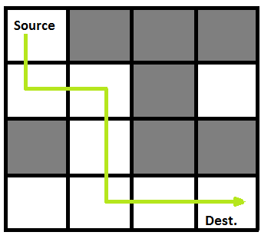

A rat starts from source and has to reach the destination. The rat can move only in two directions: forward and down.

In the maze matrix, 0 means the block is a dead end and 1 means the block can be used in the path from source to destination. For this example (according to the diagram), consider the following matrix representation:

**{1, 0, 0, 0}**

**{1, 1, 0, 1}**

**{0, 1, 0, 0}**

**{1, 1, 1, 1}**

Write a program with a recursive function to implement this maze and print the possible output path of the rat.

5. Write a function that takes a pointer to float array as parameter and checks if it contains values greater than 100.0.

6. Write a program that reads a sentence (string) as input from the user. It should then pass this sentence to a function using double pointer. The function should simply find number of vowels in each individual word of the sentence.

7. Write a program that has an array of length 10 declared in the main function. Your program should take 5 integer values in the range 25 to 50 as input from the user. It should then pass these values sequentially to a function which takes an integer parameter and returns an index of the array based on the following formula:

**Index = (Value + 3 x Value) % 10**

The 5 integer value can then be sequentially saved to the array according to the corresponding index returned for them. However, while storing each value, the following conditions must be taken into account:

1. If there is already a value stored at that index, this situation is called 'clash'. In this case, try to store the value at the next index. If it's also occupied, keep checking until you find an available slot
2. The array can be treated as being circular in nature i.e. if last index is occupied, then index 0 can be checked and it its available, it can be used to store the value.

Your program should display what is stored at each index of the array (including empty cells). It should also display how many times a 'clash' occurred for the given 5 input values.